- you’re invited to  university day at the capitol!  Never Lobbied before? No problem!  All participants will be trained and provided with appropriate background materials! Lunch and snacks are included. Please check it out on the Government & Community Relations Website, or register here.  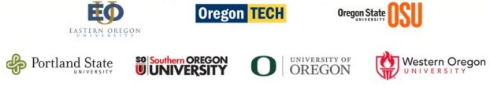 | WHEN?  Thursday,  February, 15th 2018  WHERE?  Salem, OR  WHO?  You! You’ll gain valuable experience talking  directly with lawmakers  and lobbying for increased state funding with other advocates from Oregon’s public universities!  HOW?  Sign up today  register here  government and community relations  541-346-5020  gcr@uoregon.edu

